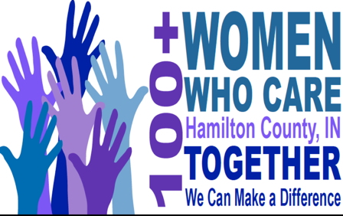

Multi-Member Team Agreement
Commitment: With our signatures below, we are agreeing that the information we provide below is accurate and true. We are pledging to participate in 100 Women Who Care Hamilton Care, and we are making a “team” commitment to contribute $400 annually ($100 quarterly) to local nonprofit organizations serving Hamilton County. We understand that as a team we only get one vote. We agree to donate each quarter to the nonprofit organization selected by the group’s majority vote. As a team, we understand that only $100 checks are turned in. Therefore, it is up to us as a team to figure out the rotation of who is actually making the $100 donation to that quarter's charity. If we are unable to attend a quarterly meeting, we will either send our check with another attending member to deliver on our behalf, mail it as requested after the meeting. We also acknowledge that photographs and videos taken at events and meetings may include our image and may be used in promotional materials for 100 Women Who Care Hamilton County.
We understand that our personal contact information is strictly confidential and we understand it will not be shared or distributed to an outside third party without our expressed consent.

Team Member #1:
First Name Address

Last Name City ST Zip

Best Phone Number Email Address

Date Signature

Team Member #2:
First Name Address

Last Name City ST Zip

Best Phone Number Email Address

Date Signature

Team Member #3:
First Name Address

Last Name City ST Zip

Best Phone Number Email Address

Date Signature

Team Member #4:
First Name Address

Last Name City ST Zip

Best Phone Number Email Address

Date Signature _______________________________________________________

